Beaufort County Department of Disabilities and Special Needs
Media Kit: Bios

Bill Love, Executive Director
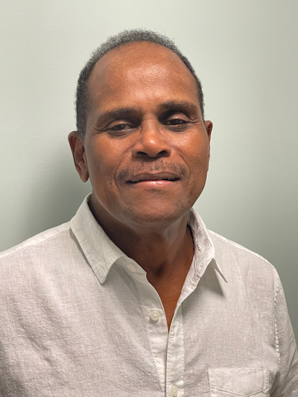 Executive Director Bill Love has been with the Beaufort County Department of Disabilities and Special Needs (BCDSN) since 2008 when he came on as director of the Day Program. He moved into his current role as executive director in 2015.

Over the years, Love has played a key role in the growth of the department. In addition to serving as a member of the team that created the new, state-of-the-art BCDSN Service and Administrative Center, he helped grow the Adult Day Program, which more than tripled in size, and he helped to create the Respite / After School Program, which provides families with activities and needed relief. Under his guidance, employment opportunities have increased significantly, and six additional residential facilities have been established.
Prior to joining the BCDSN, Love served as co-owner and vice president of Footprints Carolina, an agency in North Carolina that served more than two thousand children and adults with developmental disabilities and mental health issues.
Additionally, Love has over 30 years of experience in adult corrections and juvenile justice, having worked as deputy secretary for the Pennsylvania Department of Corrections.
Love holds a bachelor’s degree from York College in Pennsylvania and a Master of Education in Social Restoration from Lehigh University, where he was later recognized as a distinguished alum. Love taught at Penn State University while working on a Ph.D. Love is licensed as a national board-certified counselor and as a certified teacher.

Wanda Mayse, Deputy Director, Quality Assurance Coordinator. and Residential Director

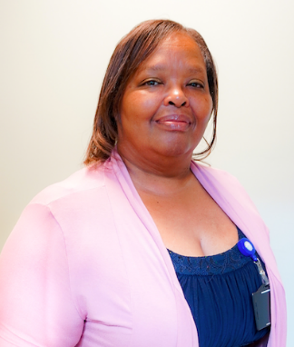
Wanda Mayse serves as the deputy director, quality assurance coordinator, and residential director for the Beaufort County Department of Disabilities and Special Needs (BCDSN). Since 2007, Mayse has directed the residential program there that provides support for 50 individuals to live independently in their communities.
Mayse previously served as program director at Brynn Marr Hospital in the Acute Inpatient Services Department. Before that, she worked for the Onslow County Mental Health and Pride in North Carolina, where she helped people of all ages with mental illnesses, developmental disabilities, and behavioral disorders.
Mayse earned her Master of Counseling from Webster University and a bachelor’s degree in speech pathology and audiology from Columbia College. She also earned certification from the South Carolina Human Services Provider Executive Leadership Academy. Mayse is a member of the American Counseling Association and the South Carolina Counseling Association.

Beth Cody, Fiscal Operations Manager
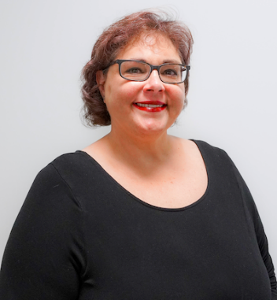
As fiscal operations manager for the Beaufort County Department of Disabilities and Special Needs (BCDSN), Beth Cody is responsible for creating and managing a $9 million dollar budget across 24 organization codes with multiple funding sources. This involves overseeing departmental expenditures to ensure that funds received from various sources are utilized in accordance with Medicaid, state, and county guidelines.

Additionally, Cody performs financial analyses, projections, and forecasts for revenue and expenditures, while also providing administrative support to comprehensive county, state, and federal audit processes, to ensure financial compliance. Other duties include training staff on financial matters and providing general IT support and training. Cody has been with the department since 2011.

Prior to joining the BCDSN, Cody served as the financial manager for Madison County Health Department in North Carolina. She holds a bachelor’s degree from Clemson University.

Cherie Scoggins, Human Services Manager

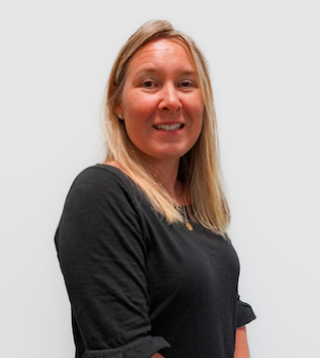
Cherie Scoggins, human services manager, first joined the Beaufort County Department of Disabilities and Special Needs (BCDSN) in 2004 as a case manager before becoming a community training home coordinator one year later. In her current role, she manages the early intervention and case management departments.

Scoggins, who holds a bachelor’s degree in Human Services from the University of South Carolina, is an active member of the board for the Ronald McDonald House Charities of the Coastal Empire. She also serves on the Beaufort County Drug Free Coalition.

Terrence Geitner, Director of Adult Services

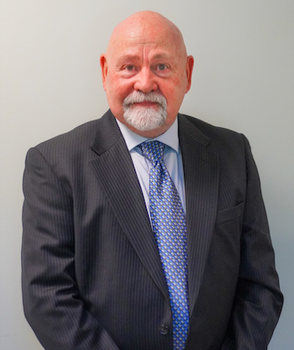
Terrence “Terry” Geitner, director of adult services for the Beaufort County Department of Disabilities and Special Needs (BCDSN), oversees a large staff that works to service 150 individuals with intellectual or related disabilities. Geitner joined BCDSN in 2015, and before taking on his current role, served as the special events organizer and project manager, orchestrating field trips, guest speakers, social functions, and Special Olympics events for the department.

Geitner holds extensive experience and a diverse background in the human services field. Before joining BCDSN, he served as director of operations for AMIkids Beaufort, a juvenile rehabilitation program designed to redirect and stabilize young men who are prone to a life of crime when intervention and role modeling are not available. Prior to that, he worked as an event manager for the Pediatric Brain Tumor Foundation, a 501-c3 non-profit organization based in Asheville, North Carolina. Additionally, he has been involved with the Big Brothers/Big Sisters organization and the YMCA.
After graduation with a bachelor’s degree in psychology from The University of Tennessee in Knoxville, Geitner accepted a position as a clinical counselor in the Child and Adolescent division at Coastal Empire Community Mental Health Center, a satellite office of the South Carolina Department of Mental Health. In that position, Geitner worked in parallel with support staff and a team of clinical psychiatrists.
Geitner, who is a past president of his HOA community, currently sits on the board for AMIkids Beaufort and is a licensed United States Coast Guard captain. He also served in the United States Marine Corps, as well as the United States Coast Guard.

Rev. 8 19 22

